Classes and Objects 2

Continue from the Fraction class%

1. Insert the constructors with the following specifications to the Fraction class:
   1. create an object given the numerator and denominator

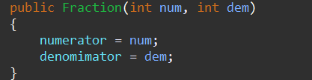

* 1. create an object which is a duplication of the given Fraction object

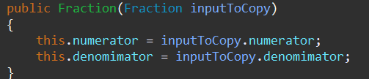

* 1. create an object that is equivalent to the given double number. For example, 0.98 is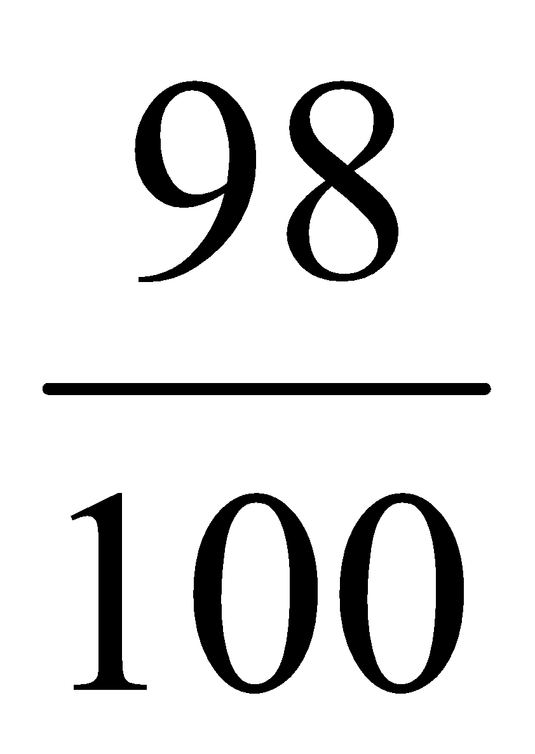, 8.343 is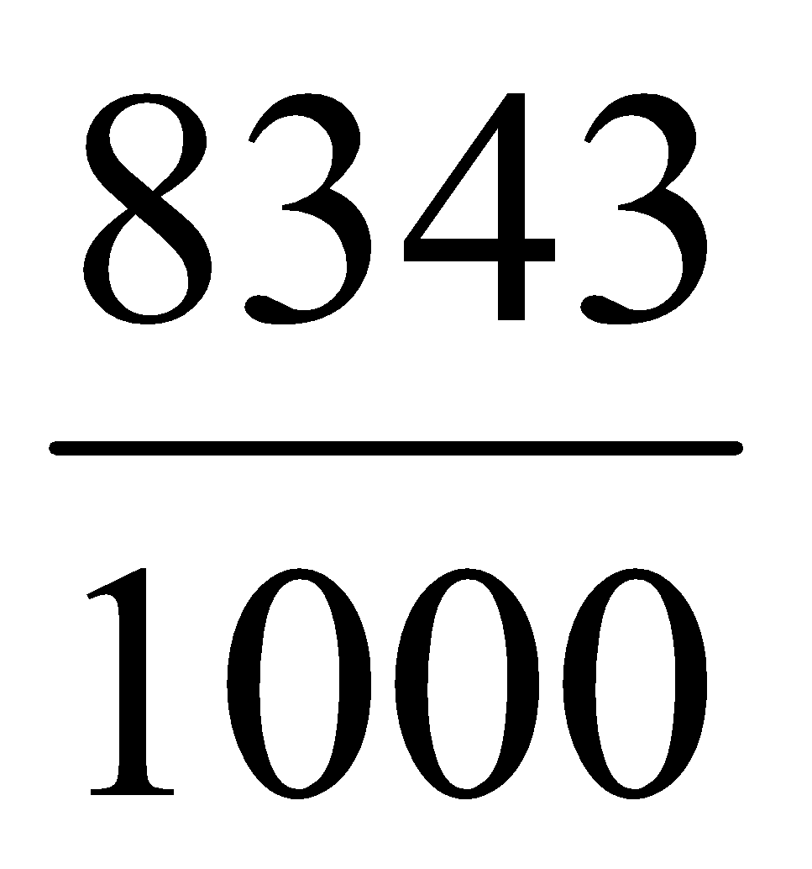. The object created does nfot have to be in reduced form. (It can be reduced by the reduce method after its creation)

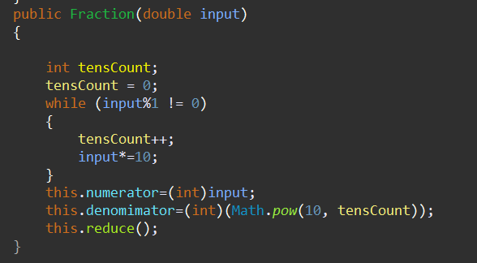

1. Make the instance fields num and den private. Write the accessor method for the num and den field.

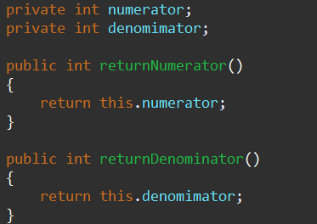

1. Write the mutator methods that modify the num and den fields. When setting the denominator, if the user supplies a value of 0, have it get set to 1 instead

.